*Z-Transform Definition*

Z[x(n)] = -n = x(z) + ROC

ROC: Region of Convergence (condition that summation converge into the last result). Integral part of Z-transform.

z: complex frequency

z = r . ejw 🡪 r: magnitude, w: angle, j: complex number

x(n): Discrete time signal in time domain

We try to convert x(n) to x(z) in z-domain which is complex frequency domain.

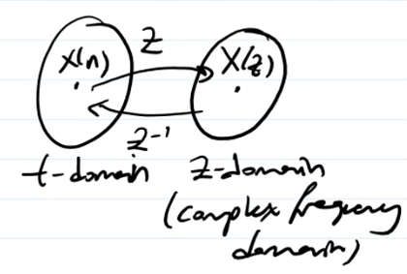

Inverse Z-Transform

*Example*:

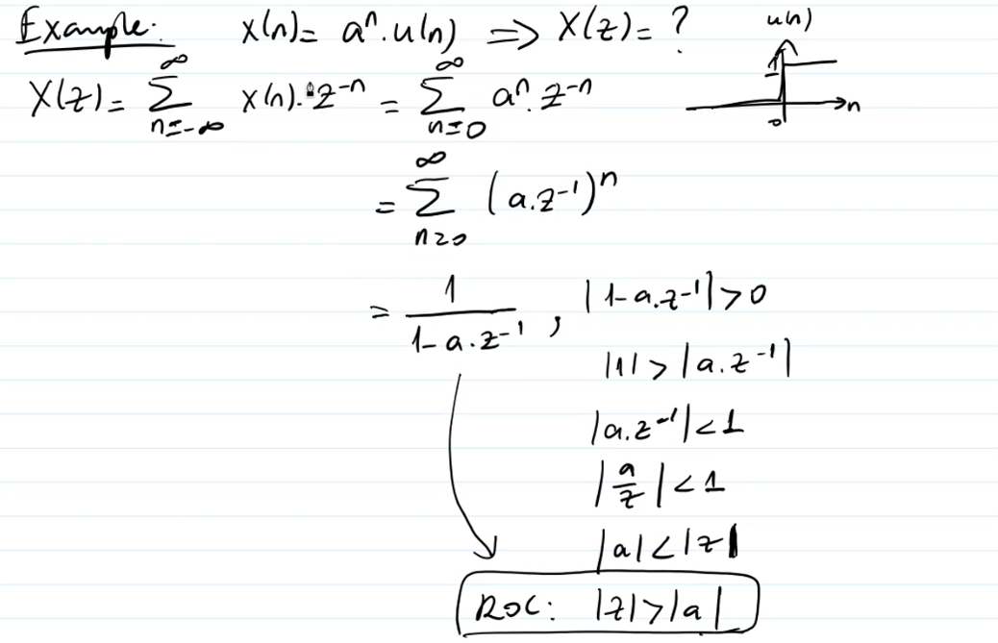

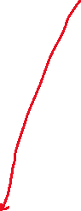

u(n) 🡪 unit step function

Question is “Can you find Z transform of given x(n) signal?”

ROC: |z| > |a| means result is valid under this condition.

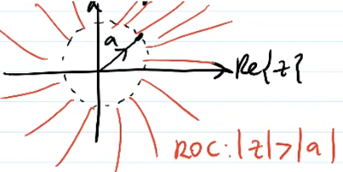

Result is valid within red region.

*Example:*

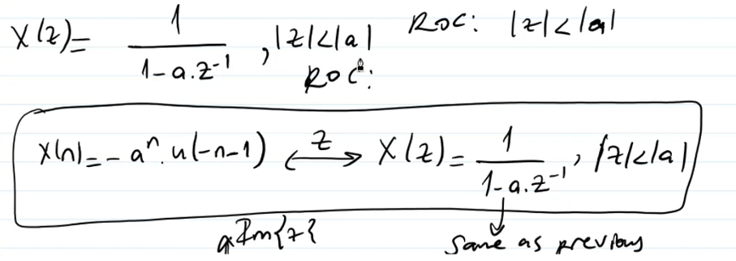

Knowledge of x(z) + ROC uniquely determines x(n).

Important Property: Linearity

The Z-transform is linear, that is (apply linearity condition):

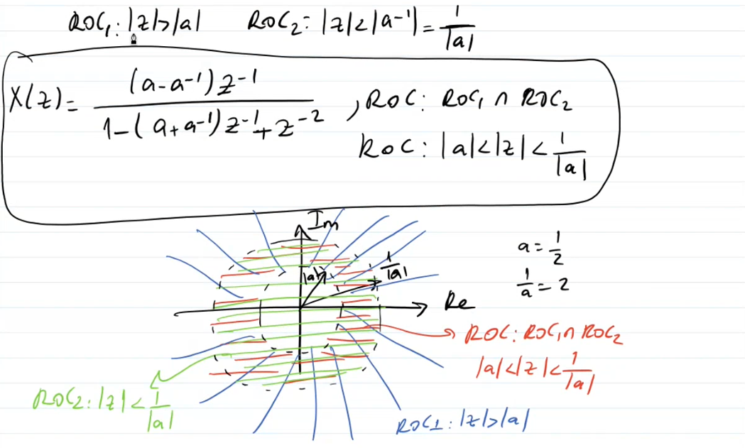

*Example:*

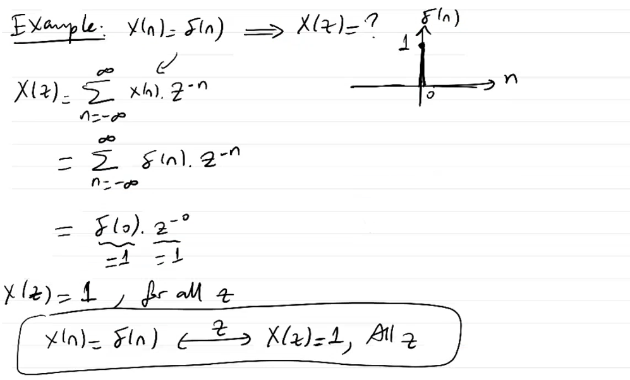

Delta (impulse) function has only non-zero value at n=0

*Example:*

*Example:*

PROPERTIES OF Z-TRANSFORM

Time-shift

*Example*:

Scaling in the Z-domain

*Example*:

Time-reversal

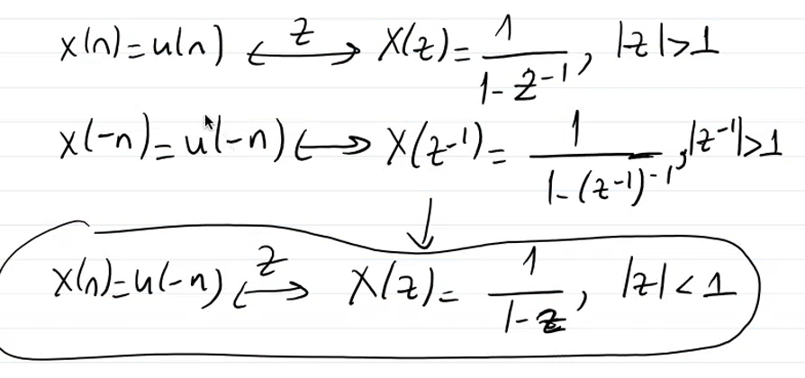*Example:*

Convolution

*Example*:

h(n) is impulse response.

x(n) is unit step function.

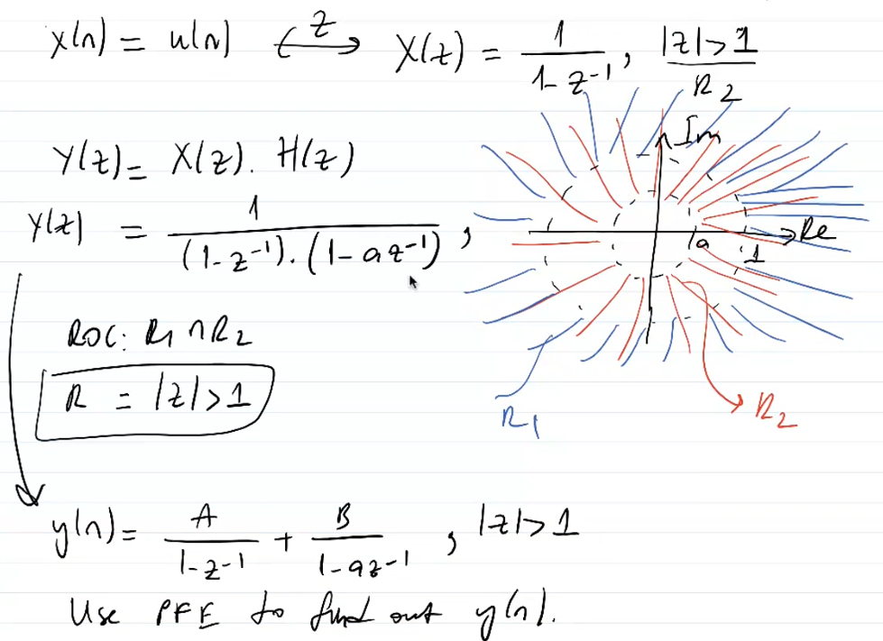



R1 ve R2’nin yerleri değiş tokuş olmalı. Yanlış yazılmış.

Inverse Z-transform.

Differentiation in the Z-domain

*Example:*

Poles and Zeros

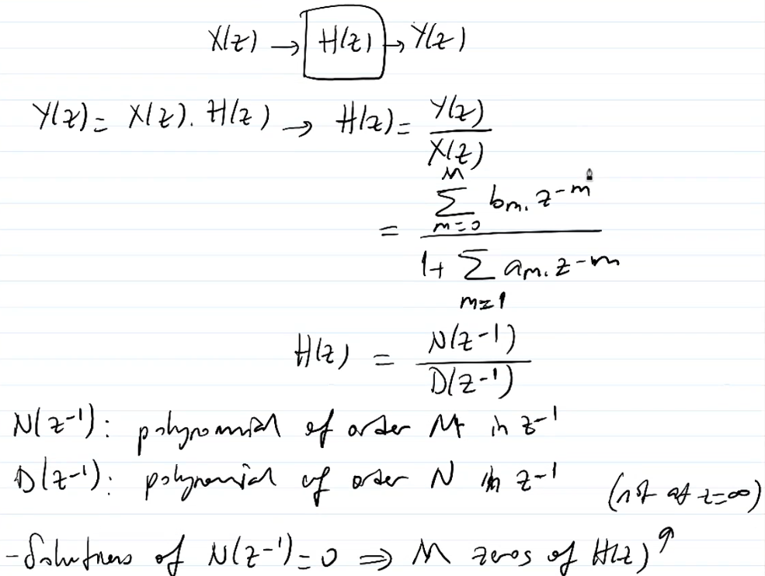

H(z) : Transfer function

N: nominator D: denominator

*Example:*

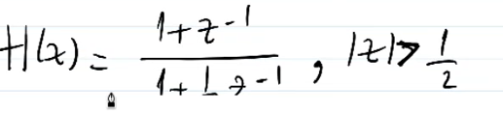

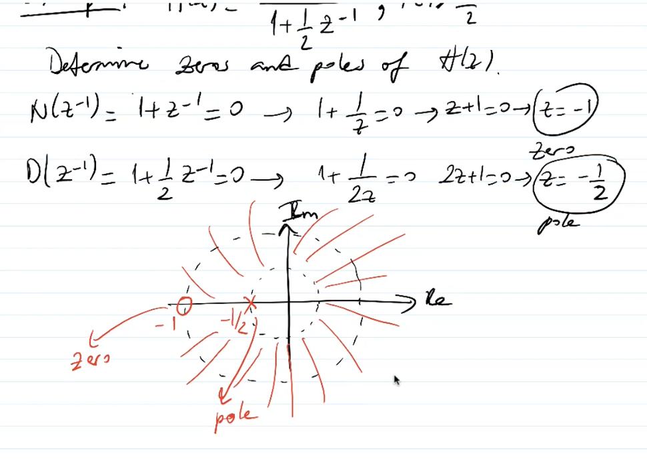

In Z-plane; Zeros is notated with circle, Poles is notated with x.